--=================================================================================
--=============================== CIS 310 Exercise 2 ===============================
--=================================================================================
/*
STUDENT NAME: Dylan Shea
STUDENT ID: 5505131
SUBMISSION DATE: 1/16/24
*/
- Turn below simplified Crow's foot ERD to business rules.
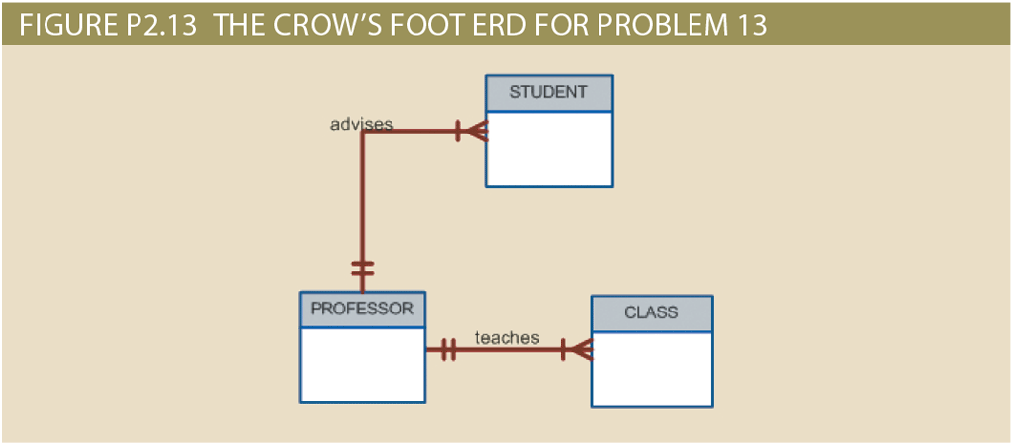

Student to Prof
BR1: each professor can give advising to one or many students.
BR2: each student receives advice from one and only one professor.

Prof to Class
BR1 Each professor can teach one or many classes.
BR2 Each Class is taught by 1 and only one professor.

- Create simplified Crow’s Foot ERDs to include the following business rules:
--I Recommend drawing/typing using OneNote and attach screenshot.
Sales company:
  - Each sales representative writes many invoices.
  - Each invoice is written by one sales representative.
  - Each sales representative is assigned to one department.
  - Each department has many sales representatives.
  - Each customer can generate many invoices.
  - Each invoice is generated by one customer.



BooksOnline Store:
During some period of time, a customer can download many ebooks from BooksOnline. Each of the ebooks can be downloaded by many customers during that period of time.

MegaCo Corp:
Each of the MegaCo Corporation’s divisions is composed of many departments. Each department has many employees assigned to it, but each employee works for only one department. Each department is managed by one employee, and each of those managers can manage only one department at a time.
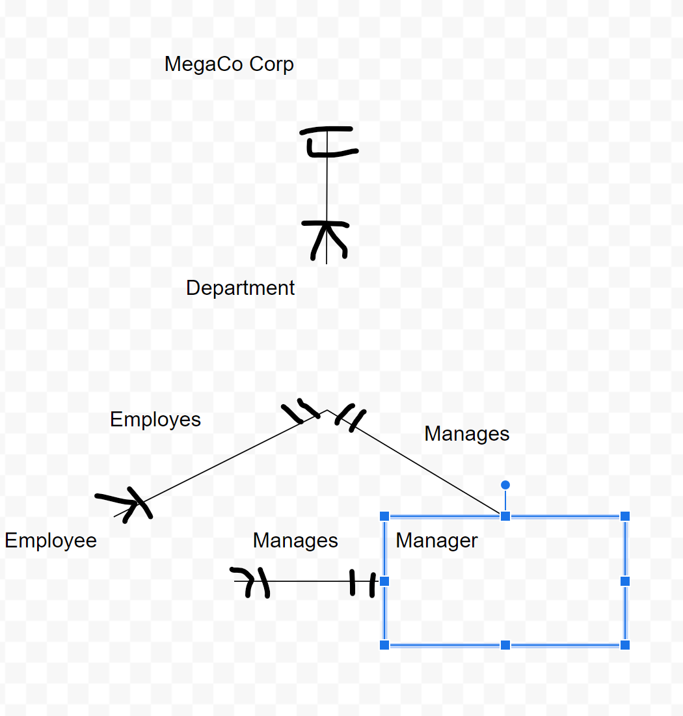

- Follow all 3 steps of instruction to download, install, and log in to VMWare. Insert screenshot of opening MS Visio within VMWare here. Example screenshot as shown. Your screenshot should reflect your full name.
For any questions or issues, contact cobhelp@louisville.edu and CC Prof.Wang jiao.wang@louisville.edu.
